
Attendance
Newsletter
Spring Term 2 2025
School Start/Finish Times

8:40am – 3.15pm

ATTENDANCE MATTTERS
Aim for 100% attendance for a better future
Every School Day Counts
Dear Parents and Carers,

Blackfordby St Margaret’s Primary School continues to place a strong focus on attendance and punctuality. We would like to thank all the children who arrive on time each day – it sets a positive tone for learning and supports their success in the classroom.

We are pleased to share with you our current attendance data below.
You will also be able to see and keep track of your child’s attendance on Arbor.

Year Group | % Attendance Spring Term 2
EYFS | 94.67%
Year 1 | 93.65%
Year 2 | 85.64%
Year 3 | 93.27%
Year Group | % Attendance Spring Term 2
Year 4 | 97.55%
Year 5 | 92.65%
Year 6 | 93.62%
Total | 93.29%


We would like to wish you all a very happy, relaxing Easter break. We hope the children enjoy their time off and stay safe over the holiday. We look forward to seeing them back in school on Monday 28th April 2025.

Reporting an Absence
It is the parent/carers responsibility to notify school if their child is absent. A reason MUST be provided. Please ensure you contact the school to advise of your child’s absence by 9.30am on the day of absence. This can be done either via telephone on 01283 217702 or email: office@blackfordby.risemat.co.uk

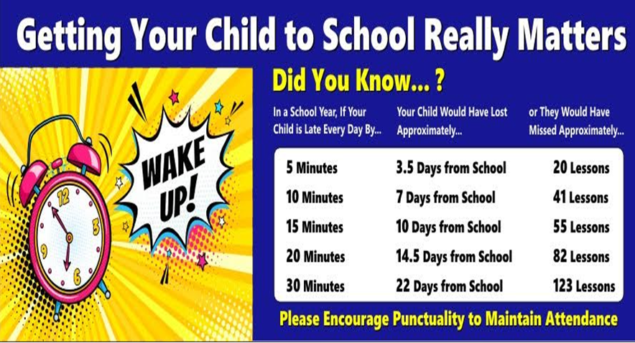

Persistent Absences
Any child with attendance below 90%, regardless of the reason of the absence,
is considered to be a persistent absentee.
This equates to just 2 days each month.
Statistics show that persistent absentees are less likely to achieve their full potential.
Unauthorised Learning Leave in Term Time (Holidays)
Children are not entitled to holidays during term time. Family holidays should be taken during school holiday periods.
To request learning leave during term time due to exceptional circumstances, ask the school office for a Learning Leave of Absence Form (with as much notice as possible).
Fines may be issued where unauthorised learning leave has been taken during term time.

Medical Evidence
Medical evidence for a pupil’s absence is not routinely requested, however, from time to time you may be
asked by the school office for medical evidence, this would usually happen when your child’s absence
from school becomes a concern.

Medical Appointments

Ensure that, where possible, hospital, doctor and dental appointments are made outside of school hours. Where this is not possible, the amount of school time missed must be kept to a minimum and medical evidence may be required.

YOUR LEGAL RESPONSIBILITY
If your child does not attend school regularly (over 90%) the Local Authority can take action against you. This can be
through a Fixed Penalty Notice (fine) or a summons to ap- pear at court.
What is a fixed Penalty Notice?
The Anti-Social Behaviour act 2003 introduced legislation for Local Authorities to issue Fixed Penalty Notice to parents/carers of pupils who have unauthorised absences from school.
A Penalty Notice can be issued for two reasons:
- If a holiday is taken during term time without the per- mission of the headteacher
- If a pupil has unauthorised absence from school and
their parent/carer fails to co-operate with school staff and/or other professionals to improve the situation

What are the fines?
From August 19th 2024
£160 per parent/carer (reduced to £80 if paid within a timely manner). If the £160 is not paid within the time frame given a summons can be issued to appear in court. The Local Authority can decide whether to issue a summons to court in- stead of a Penalty Notice.

Further information can be found at the bottom of the newsletter.

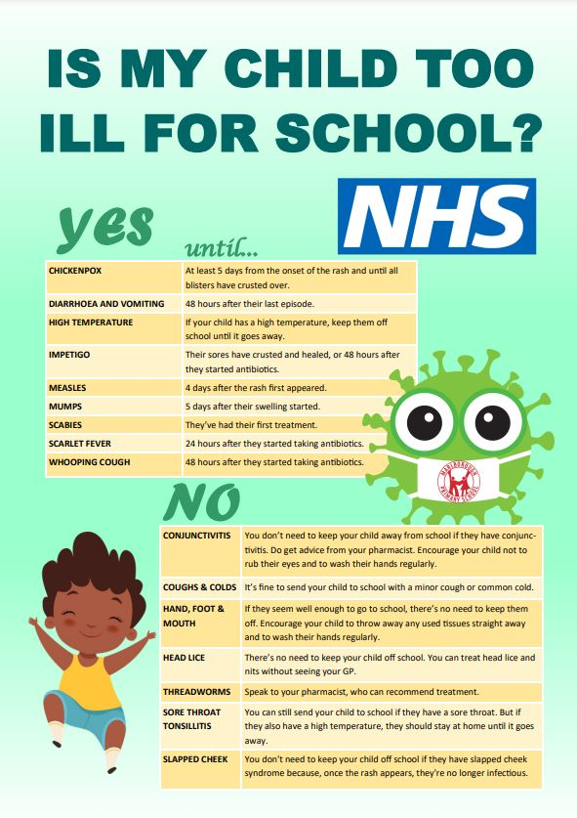

What to do if you move house/out of the area

If you move house and decide to change your child’s school, you will firstly need to apply to the Local Authority school admissions for a place at a school close to your new address (school staff can Help with this). You will also be required to complete a ‘Leavers Form’ please ask for the form at the school office.






Check your child’s attendance on Arbor

Compulsory school reminder to
Parents and Carers of the Reception Children

Parents and carers have a duty to ensure that children of compulsory school age receive a suitable education either by regular attendance at school or otherwise.

A child reaches compulsory school age the term following their fifth birthday.

Children born in..........

September, October, November & December - become compulsory January 1st 2025

January, February & March – become compulsory April 1st 2025

April, May June, July & August – become compulsory September 1st 2025

For all your Attendance enquiries

Please call the school office who will be happy to help
or connect you to the Rise Multi Academy Attendance Lead.

Penalty Notice Fines for School Absence are changing
With the introduction of the new National Framework for penalty notices, the following changes will come into force for Penalty Notice fines issued for unauthorised absence that occurs after 19th August 2024.
Further guidance is available on the Gov.uk website.
Fines for parents for taking children out of school: What you need to know – The Education Hub (blog.gov.uk)

Per Parent, Per Child
Penalty Notice fines will be issued to each parent, for each child who was absent.
For example: 3 siblings absent for term time learning leave will result in each parent receiving 3 separate fines
First Offence
The first time a Penalty Notice is issued for Term Time Learning Leave or irregular attendance the amount will be:
£160 per parent, per child when paid within 28 days
Reduced to £80 per parent, per child if paid within 21 days.
Third Offence and Any Further Offences (within 3 years)
The third time an offence is committed for Term Time Learning Leave or irregular attendance a Penalty Notice will not be issued. The case will proceed to the Magistrates’ court. Magistrates’ fines can be up to £2,500 per parent, per child.
Cases found guilty in a Magistrates’ Court can show on the parents future DBS certificate and may impact on job applications and travel abroad.
Court Prosecutions
Penalty Notices will not automatically be issued. Parents are advised that where the Local Authority considers that a Penalty Notice is not appropriate due to the level of concern about a child’s absence, prosecution action may be taken.
BY LAW, ALL PENALTY NOTICE PAYMENTS GO TO THE LOCAL AUTHORITY AND NOT TO SCHOOLS
Second Offence (within 3 years)
The second time a Penalty Notice is issued for Term Time Learning Leave or irregular attendance the amount will be:
£160 per parent, per child when paid within 28 days.
There is NO option to pay at £80 level
10 Sessions of Unauthorised Absence in a 10-week period
Penalty Notice fines will be considered when there have been 10 sessions of absence in a 10-week period
Sessions equal to AM & PM
5 Consecutive Days of Term Time Learning Leave
Penalty Notice fines will be issued for term time learning leave of 5 or more consecutive days and for fewer days where this has happened before.

