
Blackfordby St Margaret’s C of E
Primary School

Special Education Needs and Disabilities (SEND) Policy

Signed:
Mrs Culpan (SENDCO)

Inclusion Statement
Blackfordby provides a broad and balanced curriculum for all children including those with special educational needs or disabilities. We are committed to inclusion for all children in all areas of the curriculum. Individual needs will be met through the highest quality of education for all pupils and the efficient and effective use of resources.

1 Introduction
1.1 The National Curriculum is our starting point for planning that meets the specific needs of individuals and groups of children. When planning, teachers set suitable learning challenges and respond to children’s diverse learning needs. Some children have particular learning and assessment requirements that could create barriers to learning. These barriers can be classified as one of the following:

- communication and interaction
- cognition and learning
- social, emotional and mental health difficulties
- sensory and/or physical needs

  - These requirements are likely to arise as a consequence of a child having special educational needs. Teachers take account of these requirements and make provision, where necessary, to support individuals or groups of children and thus enable them to participate effectively in curriculum and assessment activities.

  - Children may have special educational needs either throughout, or at any time during, their school career. This policy ensures that curriculum planning and assessment for children with special educational needs takes account of the type and extent of the difficulty experienced by the child.

2 Aims and objectives
2.1 The aims of this policy are:
to create an environment that meets the special educational needs of each child;
- to ensure that the special educational needs of children are identified, assessed and provided for;
- to make clear the expectations of all partners in the process and how parents and pupils play a key role in the process;
- to identify the roles and responsibilities of staff in providing for children’s special educational needs;
- to enable all children to have full access to all elements of the school curriculum.
- to outline how the school fulfils statutory duties as outlined in SEND Code of Practice (2014)
•

3 Educational inclusion
3.1 Through appropriate curricular provision, we respect the fact that children:
- have different educational and behavioural needs and aspirations;
- require different strategies for learning;

- acquire, assimilate and communicate information at different rates; need a range of different teaching approaches and experiences.

3.2 Teachers respond to children’s needs by:
- providing support for children who need help with communication, language and literacy; planning to develop children’s understanding through the use of all available senses and experiences;
- planning for children’s full participation in learning, and in physical and practical activities;
- helping children to manage their behaviour and to take part in learning effectively and safely;
- helping individuals to manage their emotions, particularly trauma or stress, and to take part in learning.
- work with parents/carers who know their children the best.
Please see attached appendices – SEND annual schedule and SEND assessment

4 Special educational needs
4.1 With reference to the SEND Code of Practice (2014):
A child or young person has SEND if they have a learning difficulty or disability which calls for special educational provision to be made for him or her.
A child of compulsory school age or a young person has a learning difficulty or disability if he or she:
- has a significantly greater difficulty in learning than the majority of others of the same age, or
- has a disability which prevents or hinders him or her from making use of facilities of a kind generally provided for others of the same age in mainstream schools or mainstream post-16 institutions.

Class teachers, supported by the SENDCO, make regular assessments of progress for all pupils. These should seek to identify pupils making less than expected progress given their age and individual circumstances. This can be characterised by progress which:
- is significantly slower than that of their peers starting from the same baseline
- fails to match or better the child’s previous rate of progress
- fails to close the attainment gap between the child and their peers
- widens the attainment gap

4.2 In our school the role of the Special Educational Needs Co-ordinator (SENDCO) is:

- overseeing the day-to-day operation of the school’s SEND policy
- co-ordinating provision for children with SEND
- liaising with the relevant Designated Teacher where a looked after pupil has SEND  advising on the graduated approach to providing SEND support
- advising on the deployment of the school’s delegated budget and other resources to meet pupils’ needs effectively
- liaising with parents of pupils with SEND
- liaising with early years providers, other schools, educational psychologists, health and social care professionals, and independent or voluntary bodies
- being a key point of contact with external agencies, especially the local authority and its support services
- liaising with potential next providers of education to ensure a pupil and their parents are informed about options and a smooth transition is planned
- working with the Executive Headteacher and school governors to ensure that the school meets its responsibilities under the Equality Act (2010) with regard to reasonable adjustments and access arrangements
- ensuring that the school keeps the records of all pupils with SEND up to date
(SEND Code of Practice, 2014)

5 The role of the Governing Body
5.1 The Governing Body ensures Blackfordby secures the necessary provision for any pupil identified as having SEND. They support school provision for SEND by monitoring the provision and progress for SEND children and ensuring its policies and practices follow the latest code of practice and statutory guidance.

5.2 The Governing Body ensures a fair and transparent system for children to be admitted to the
school in line with the Local Authority’s agreed admissions policy.

6 Allocation of resources
6.1 The SENDCO is responsible for the operational management of the specified and agreed resourcing for special needs provision within the school, including the provision for children with Educational Health and Care Plans.

6.2 Planned expenditure is overseen by the Finance Committee. The Executive Headteacher informs the governing body of how funding allocated to support SEND has been used.

7 Assessment (for more information see appendix 2)

Monitoring children’s progress
7.1 Early identification is vital. The class teacher informs parents at the earliest opportunity to alert them to concerns and enlist their active help and participation. Teachers are responsible and accountable for the progress and development of the pupils in their class, including where pupils access support from teaching assistants or specialist staff. High quality teaching, differentiated for individual pupils, is the first step in responding to pupils who have or may have SEND. Additional intervention and support cannot compensate for a lack of good quality teaching. The school regularly and carefully reviews the quality of teaching for all pupils, including those at risk of underachievement. This includes reviewing and, where necessary, improving, teachers’ understanding of strategies to identify and support vulnerable pupils and their knowledge of SEND provision.

7.2 The class teacher and the SENDCO assess and monitor children’s progress in line with existing school practices. This includes talking to the child about their progress and what they feel their strengths and areas for development might be.

7.3 The SENDCO works closely with parents and teachers to plan an appropriate programme of intervention and support.

7.4 The assessment of children reflects as far as possible their participation in the whole curriculum of the school. The class teacher and the SENDCO can break down the assessment into smaller steps in order to aid progress and provide detailed and accurate indicators.

7.5 The school will always encourage children’s needs to be met through quality first teaching, targeted at the areas of weakness. Where appropriate, the child’s needs will be met through targeted intervention with a designated adult or focus group. This will be outlined on the school’s provision mapping or part of each classes intervention plans.

SEND support
7.6 If after various interventions a child’s progress is still a concern, the child will be given an individual education plan (IEP) in consultation with parents. At Blackfordby this is called a Pupil Passport. Parents will be involved in the setting of intended outcomes. Children will also be involved in discussing intended outcomes and their role with achieving these targets. The process of setting up an IEP will follow the graduated approach to SEND support (see SEND Code of Practice 2014 6.44). This four part cycle of Assess, Plan, Do, Review will include intended outcomes, details of provision, clear success criteria and a clear date for review. These IEPs will be reviewed termly by teachers, SENDCO, parents and pupils.

7.7 It may be necessary for the school to involve other agencies within the support the individual children. If pupils continue to make less than expected progress or the school needs advice on early identification and support or intervention, specialist involvement will be sought with the parents’ permission.

7.8 Children who require specialist involvement or have a range of interventions that need to be co-ordinated are placed on an SEND support plan. The purpose of this plan is to bring together targeted interventions from Health, Education and Social Services, outline SEND needs and seek views of parents/carers and the child.

Requesting an Education, Health and Care Plan
7.9 Where despite the school having taken relevant and purposeful action to identify, assess and meet the needs of a child or young person, the child or young person has not made expected progress, the school or parents should consider requesting an Education, Health and Care needs assessment.

Education, Health and Care Plan
7.8 The LA seeks a range of advice before an Education, Health and Care plan is developed. This plan incorporates support from a number of different services. The needs of the child are considered to be paramount in this.

8 Access to the curriculum
8.1 All children have an entitlement to a broad and balanced curriculum, which is differentiated to enable children to:
- understand the relevance and purpose of learning activities;
- experience levels of understanding and rates of progress that bring feelings of success and achievement.

  - Teachers use a range of strategies to meet children’s special educational needs. Lessons have clear learning objectives; we differentiate work appropriately, and we use assessment to inform the next stage of learning.

  - Individual Education Plans, which employ a small-steps approach, feature significantly in the provision that we make in the school. By breaking down the existing levels of attainment into finely graded steps and targets, we ensure that children experience success. All children on the special needs register have an IEP.

  - We support children in a manner that acknowledges their entitlement to share the same learning experiences that their peers enjoy. Wherever possible, we do not withdraw children from the classroom situation. There are times though when, to maximise learning, we ask the children to work in small groups, or in a one-to-one situation outside the classroom.

9 Partnership with parents
9.1 The school prospectus and the school’s Local Offer (available on the school’s website) contains details of our policy for SEND, and the arrangements made for these children in our school.

9.2 At all stages of the process, the school keeps parents fully informed and involved. We take account of the wishes, feelings and knowledge of parents at all stages. We encourage parents to make an active contribution to their child’s education.

9.3 The class teacher and SENDCO has regular meetings each term to share the progress of SEND children with their parents. The school gives more time to these meetings outside the time restraints of the regular parents evening. The parents also receive a written report about their child’s progress once a year. We inform parents of any outside intervention, and we share the process of decision-making by providing clear information.

9.4 Parents are made aware of the school’s complaint policy through the school website. This should be followed if parents have any concerns about the provision put in place for their child that have not been resolved in discussion with their class teacher.

10 Involvement of pupils
10.1 At all stages of the SEND process, the views and attitudes of the children are sought to ensure that they are fully involved in the understanding of their needs and how they can improve their learning. The seeking of views and attitudes of children is done so according to their individual abilities of communication. Involvement in their provision is not compromised for children who need support with communication skills.

11 Monitoring and evaluation
11.1 The SENDCO monitors the movement of children within the SEND system in school. The
SENCO provides staff and governors with regular summaries of the impact of the policy on
the practice of the school. All staff and SENDCO meet once per term to discuss every child where there a is concern.

11.2 The SENDCO is involved in supporting teachers involved in drawing up Individual Education Plans for children. The SENDCO and the Executive Headteacher meet frequently to review the work of the school in this area. The SENDCO and the Governor who is overseeing any monitoring of SEND also meet to monitor and discuss progress.

11.3 The Governing Body reviews this policy and considers any amendments in light of the annual review findings. The SENDCO reports the outcome of the review to the full Governing Body.

Appendix 1 - SEND Annual Schedule
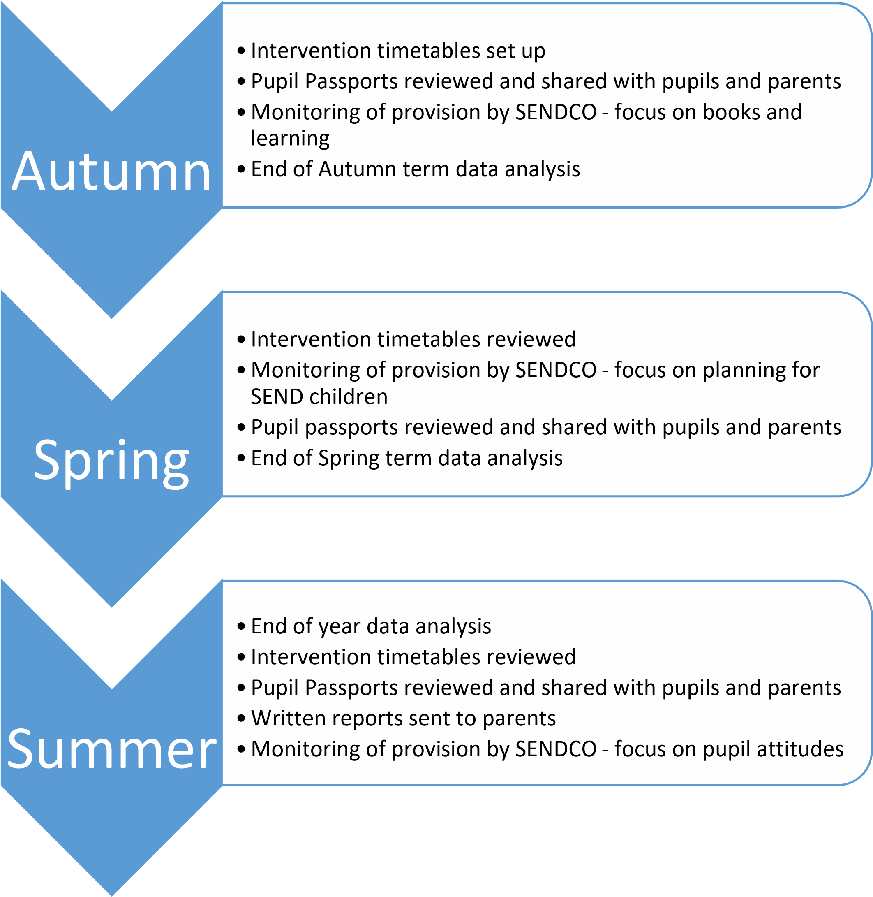
Over the year, monitoring will also take place with Governors at least once.
Early intervention and screening tests can be given to children at any time during the year as progress is monitored. Children can be given an IEP at any time across the year and meetings with parents can be arranged at any point to discuss progress.

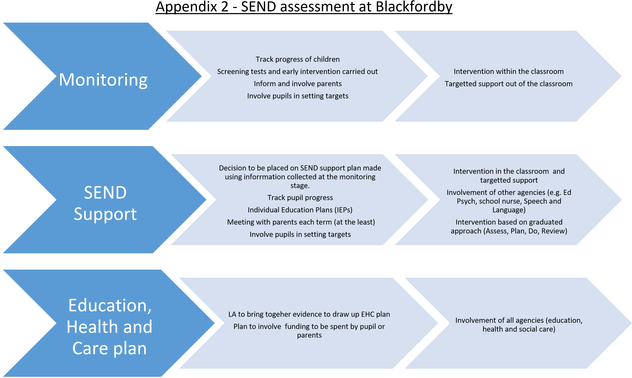

Appendix 3 – SEND assessment at Blackfordby


